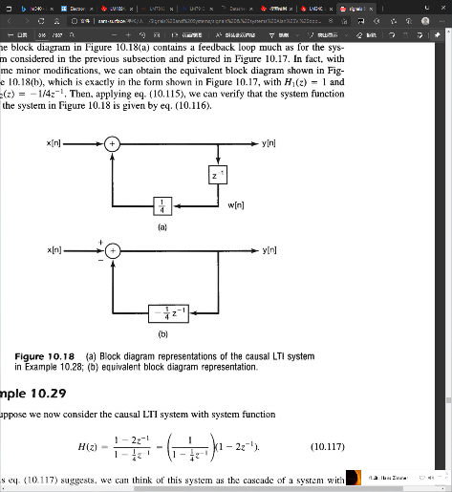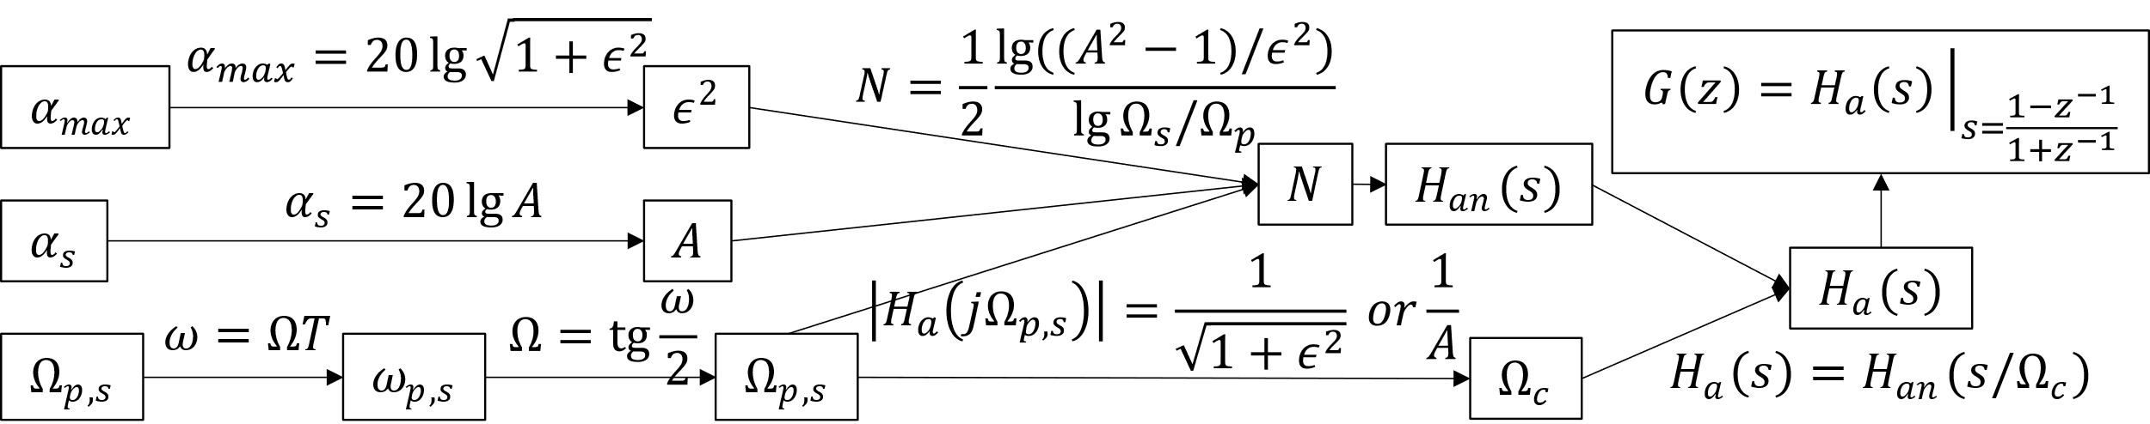

**IIR Direct Form II**

$H\left(z\right)=\frac{1-\frac{7}{4}z^{-1}-\frac{1}{2}z^{-2}}{1+\frac{1}{4}z^{-1}-\frac{1}{8}z^{-2}}$, $H\left(z\right)=\frac{1}{1-\frac{1}{4}z^{-1}}$

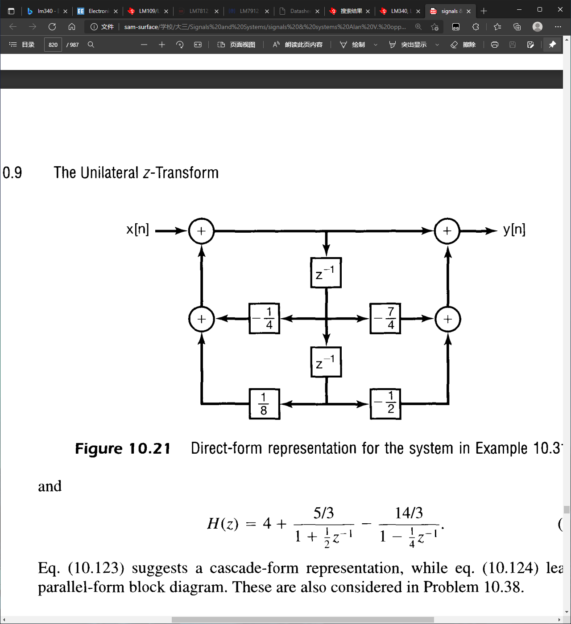

**FIR Direct Form & Linear Phase**

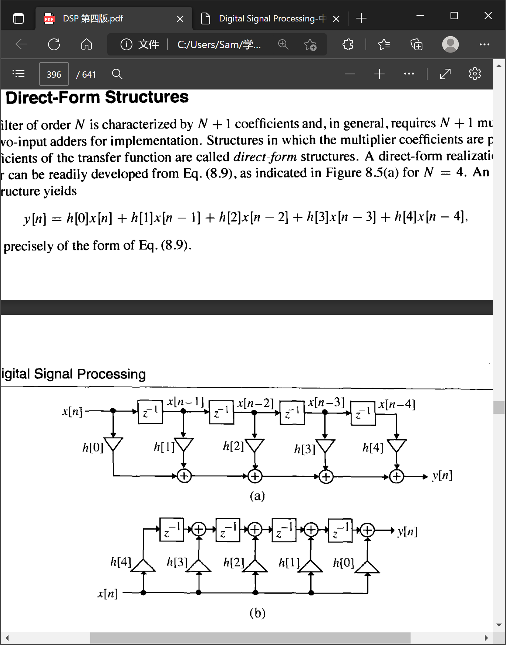

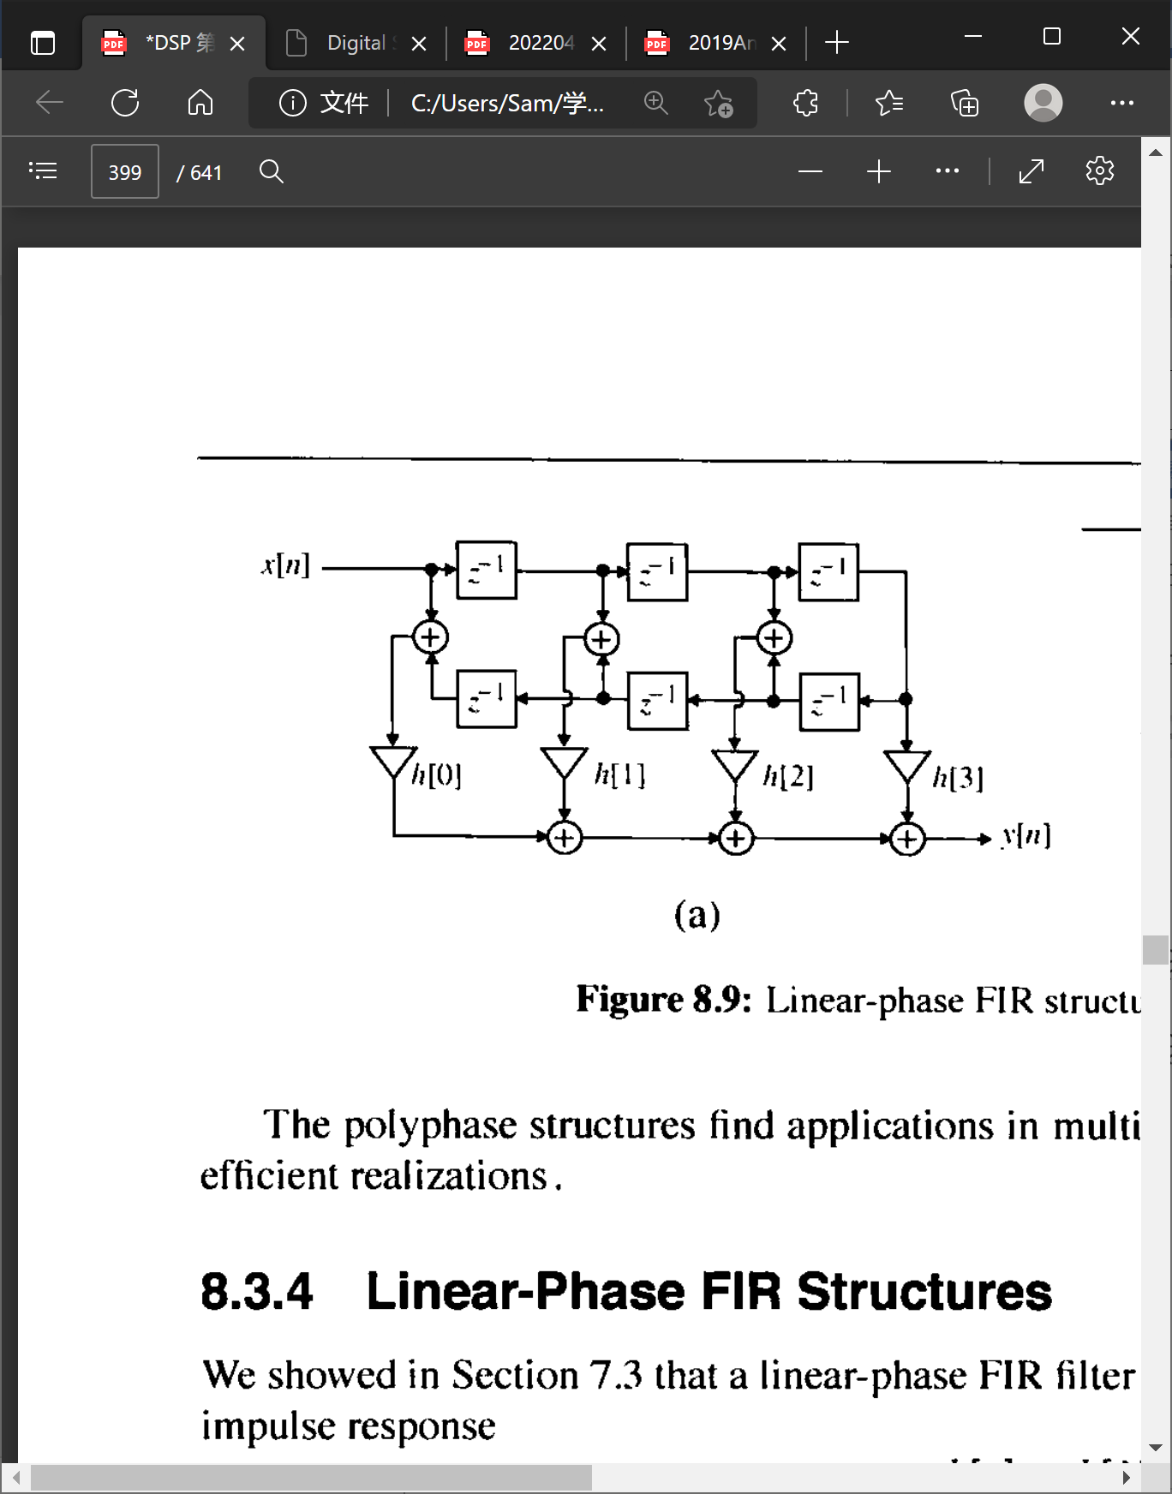

$$\frac{1}{1-αe^{-jω}}=\frac{1}{1-αe^{-jω}}·\frac{1-αe^{jω}}{1-αe^{jω}}=\frac{1-α\cos{ω}-jα\sin{ω}}{1-2α\cos{ω}+α^{2}}=\frac{1}{\sqrt{1-2α\cos{ω}+α^{2}}}∢\arctan\left(-\frac{α\sin{ω}}{1-α\cos{ω}}\right)$$

**DFT Transform Pairs**

|  |  |
| --- | --- |
| **Signal** | **Transform** |
| $$δ\left[n\right]$$ | $$1$$ |
| $$δ\left[n-m\right]$$ | $$W_{N}^{km}$$ |
| $$\cos\left(\frac{2π}{N}rn\right)$$ | $$\left\{\begin{aligned}&\frac{N}{2}, k=r or N-r \\ &0, otherwise\end{aligned}\right.$$ |
| $$\sin{(\frac{2π}{N}}rn)$$ | $$\left\{\begin{aligned}&\frac{N}{2j}, k=r \\ &-\frac{N}{2j}, k=N-4 \\ &0, otherwise\end{aligned}\right.$$ |

**Butterworth Filter**

$${\left|H_{a}\left(jΩ\right)\right|}^{2}=\frac{1}{1+{\left(Ω/Ω_{c}\right)}^{2N}}$$

**DFT关键公式**

$$\frac{1}{N}\sum_{n=0}^{N}{e^{j\frac{2π}{N}\left(k-l\right)n}}=\left\{\begin{aligned}&1, k=l+rn \\ &0, k≠l\end{aligned}\right.$$

$$W_{N}=e^{-j\frac{2π}{N}}, \cos\left[\frac{2π}{N}rn\right]=\frac{1}{2}\left(W_{N}^{rn}+W_{N}^{-rn}\right)$$

**DTFT Transform Pairs**

|  |  |
| --- | --- |
| **Signal** | **Transform** |
|  |  |
|  |  |
|  |  |
|  |  |
|  |  |
|  |  |
|  |  |
|  |  |
|  |  |

**Z-Transform Pairs**

|  |  |  |  |
| --- | --- | --- | --- |
| **Signal** | **Transform** | | **ROC** |
| $$δ\left[n\right]$$ | $1$ | | All |
|  |  | |  |
|  |  | |  |
|  |  | All $z$, except 0 or | |
|  |  | |  |
|  |  | |  |
|  |  | |  |
|  |  | |  |
|  |  | |  |
|  |  | |  |
|  |  | |  |
|  |  | |  |

**IIR Filter Design**

①对比两个 $α$ 选窗

② $Δω$ 算 $M$

③ $N=2M+1$

④ $h\left[n\right]=h_{LP}\left[n-M\right]w\left[n-M\right]$

**P-Series Test**

$\sum_{n=1}^{∞}{\frac{1}{n^{p}}}$ converges

for $p≥1$

**Theorems**

|  |  |  |  |  |  |
| --- | --- | --- | --- | --- | --- |
| **Property** | **Signal** | **DTFT** | **DFT** | **Z-Transform** | **ROC** |
| Linearity | $$ax\left[n\right]+by\left[n\right]$$ | $$aX\left(e^{jω}\right)+bY\left(e^{jω}\right)$$ | $$aX\left[k\right]+bY\left[k\right]$$ | $$aX_{1}\left(z\right)+bX_{2}\left(z\right)$$ | At least $R_{1}∩R_{2}$ |
| Time Shifting | $$x\left[n-n_{0}\right], x\left[{〈n-n_{0}〉}_{N}\right]$$ | $$e^{-jωn_{0}}X\left(e^{jω}\right)$$ | $$W_{N}^{kn_{0}}X\left[k\right]$$ | $$z^{-n_{0}}X\left(z\right)$$ | $R$ except for possible origin |
| Frequency Shifting  (Z-Domain Scaling) | $$e^{jω_{0}n}x\left[n\right], W_{N}^{-k_{0}n}x\left[n\right]$$ | $$X\left(e^{j\left(ω-ω_{0}\right)}\right)$$ | $$X\left[{〈k-k_{0}〉}_{N}\right]$$ | $$X\left(e^{-jω_{0}}z\right)$$ | $$R$$ |
| Time Expansion | $$x_{\left(k\right)}\left[n\right]=x\left[\frac{n}{k}\right] if n=mk else 0$$ | $$X\left(e^{jkω}\right)$$ |  | $$X\left(z^{k}\right)$$ | $$R^{\frac{1}{k}}$$ |
| Convolution | $$x\left[n\right]*y\left[n\right]$$ | $$X\left(e^{jω}\right)Y\left(e^{jω}\right)$$ | $$X\left[k\right]Y\left[k\right]$$ | $$X\left(z\right)Y\left(z\right)$$ | At least $R_{1}∩R_{2}$ |
| Multiplication | $$x\left[n\right]y\left[n\right]$$ | $$\frac{1}{2π}\int_{2π}^{ }{X\left(e^{jθ}\right)Y\left(e^{j\left(ω-θ\right)}\right)dθ}$$ | $$\frac{1}{N}\sum_{m=0}^{N-1}{X\left[m\right]Y\left[{〈k-m〉}_{N}\right]}$$ | $$\frac{1}{2πj}\oint_{C}^{ }{X\left(v\right)H\left(\frac{z}{v}\right)v^{-1}dv}$$ | At least $R_{1}R_{2}$ |
| Differencing in Time | $$x\left[n\right]-x\left[n-1\right]$$ | $$\left(1-e^{-jω}\right)X\left(e^{jω}\right)$$ |  | $$\left(1-z^{-1}\right)X\left(z\right)$$ | At least |
| Accumulation | $$\sum_{k=-∞}^{n}{x\left[k\right]}$$ | $$\frac{1}{1-e^{-jω}}X\left(e^{jω}\right)$$ |  | $$\frac{1}{1-z^{-1}}X\left(z\right)$$ | At least |
| Differentiation in Frequency | $$nx\left[n\right]$$ | $$j\frac{dX\left(e^{jω}\right)}{dω}$$ |  | $$-z\frac{dX\left(z\right)}{dz}$$ | $$R$$ |

**变换**

|  |  |  |  |
| --- | --- | --- | --- |
| **CTFT** | **DTFT** | **DFT** | **Z-transform** |
| 时域连续非周期 频域连续非周期 | 时域离散非周期 频域连续周期 | 时域离散周期 频域离散周期 |  |
|  |  |  |  |
|  |  |  |  |
|  |  |  | with inverted $R$ |